CELEBRATION OF SIKHYA JAGARANA SAPTAHA AT BADMAHESWAR PRIMARY SCHOOL
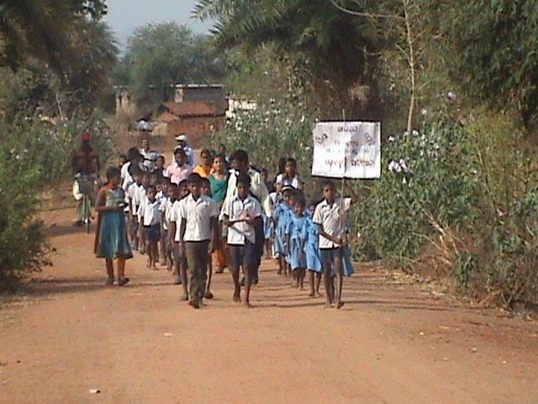
Students, teacher and parents are three most importance aspects of a school. Faith and understanding among them are factors most useful for good school governance. Realizing the fact SMC of many schools from LAMP operational villages celebrates Sikhya Jagarana Saptaha/Divas on 1st April 2012. One among them is SMC of Badmaheswar Primary school. After a long one week Prabhat pheri (Morning Railly) by School students for awareness generation on regularize children to school, on 1st April Special Prabhat Pheri was organized. Then in a community meetings parents take oath that village school is their school and all its good and bad are theirs. They promised their children to send them (their children) regularly to school. During the community meeting students worship their teachers and teachers promised to regard students. New comers (Class one students) were well come by elder children. Children sing songs, make fun, show play and have Sambalpuri dance on RTE. Adolescent girls group, youth group and SHG mothers help in organizing the program. Here are some nice photographs of the celebration.
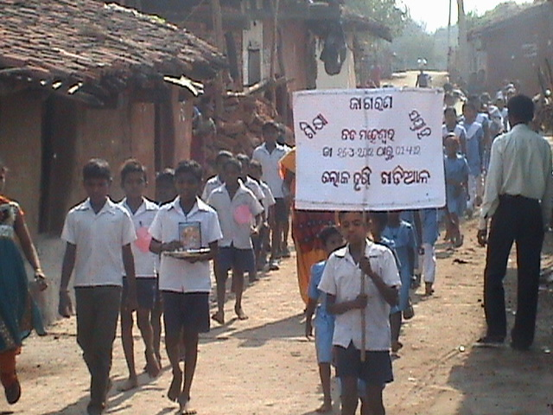
Prabhatpheri (Railly) for awareness generation by students
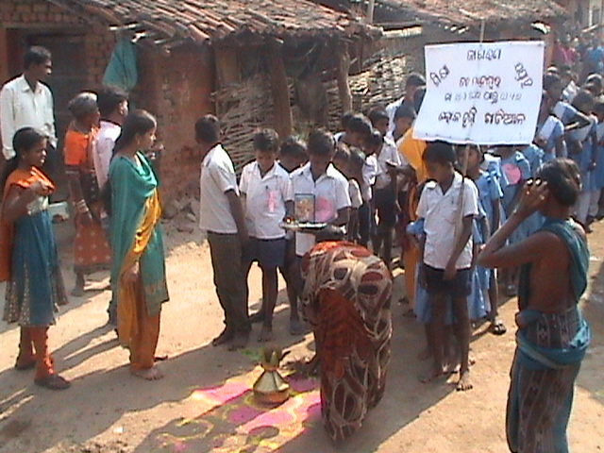
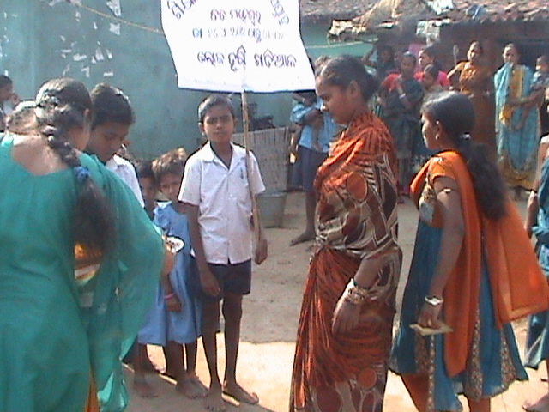
Mothers well comes children and promising to send them regularly to school

