A STEP FORWARD TOWARDS SCHOOL REFORM

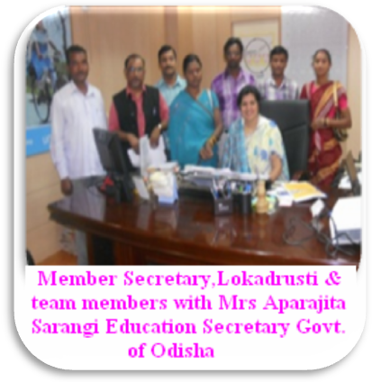
LAMP’s deliberate efforts for community awareness on RTE and mobilizing SMCs for school reforms resulted when on dt.26.12.2011 Mrs.Aparajita Sarangi, then Education Secretary cum commissioner of Odisha accepted and appraised the School Development Plan submitted to her by Mr.Rikhiram Majhi, SMC Chairperson of Khamtarai Primary School, one among the 8 members team from Lokadrusti meets Mrs.Sarangi at her chamber in Odisha Secretariat. Mr.Bhubaneswar Rout, Program Head of LAMP, Lokadrusti also meets Mr.Rajesh Barma, the present Education Secretary cum commissioner on dt.15.03.12 at his office and submitted one another SDP for his information. Also during various meetings and trainings copies of model SDP were provided to DPC and BRCCs. At various forums and trainings those SDPs were accepted as materials for reference and a revise format was developed for all schools in the State. Thus, we were able to intervene at State Government policy level on preparation of School Development Plan. DPC Nuapada stated in a meeting with Mr.Bhubaneswar Rout, how model SDP helped them for discussion on SDP at State level. Also found all the points of model SDP accepted in the revise SDP format while comparing both the formats.
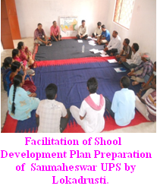
These encourage us to bring forward our initiatives to the BRCC/CRCC and Govt. school teacher, who are the ground level authorities for implementation of RTE act. First we translate the English SDP format by Education department into Odia. Then in a meeting of SMC of Sanmaheswar Upper Primary school we examine the format and prepare SDP of the same school as per it. It was done with the advice of Abaniji, Member Secretary, Lokadrusti. He himself presents in the meeting for facilitation.

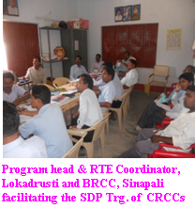
Then we talk with BRCCs of all 5 blocks on the matter and request them to provide us opportunities to share the SDP formats with CRCCs at block level meetings. All of them agreed and fix dates for the meetings. In Chairmanship of Mr.Rudreswar Meher, BRCC, Sinapali we sit in a meeting with all 17 CRCCs of Sinapali block on dt.10.04.12. Amrish and Bhimsen, our block coordinators at Sinapali organized the program. There we shared both the English and Odia SDP format in a presentation by projector. Where all points in the format discussed minutely and doubts clear by BRCC. Thus, CRCCs understand and realizes the importance of SDP.
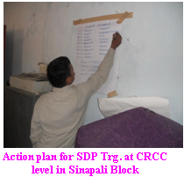
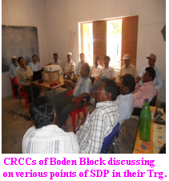
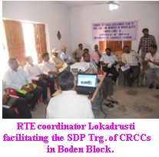
An action plan has been prepared to orient School teachers (HMs) and SMC members at cluster level. It was decided that CRCCs will inform the participants and arrange the venue where as Lokadrusti will provide materials, resource person and refreshment cost. As in Sinapali block meetings of CRCCs was also organized at Boden block on dt.16.04.12 in which BRCC, SI of school and CRCCs participated and share their valuable suggestions. In both the meetings steps of SDP, school catchment area, age of children for admission (practically 5 years children get admission to class 1st), budgeting for teachers salary (Difference salary pattern prevails for regular, SS and GS category of teachers ), teachers requirement, provision of safe and adequate drinking water facility, use of toilet, provision of land both for class rooms and play ground, ensuring retention specially in remote area and girls, management of RCC, process of special training for students not in age appropriate learning etc are the major points of discussion.

As per planning six trainings were organizes at cluster level till date in Sinapali block. Details of trainings are as follows.
Deliveries: Training on School Development Plan
Objective: To orient the SMC members on steps of SDP preparation and it’s contains.
Participants: CRCC, HM/teachers of Govt. /aided school, SMC Chairperson/members
Materials: Leaflet on key norms of RTE Act 2009 and Rights of child in the school as per RTE, SMC book by Dayaramji, Odia SDP format.
Process: Sharing/Group discussion
Nos. of school participated:
Concerted |  |  |  | Broad base |  |  |  | New Villages |  |  |  | Total
Villages | Primary | UPS | High school | Villages | Primary | UPS | High school | Villages | Primary | UPS | High school | Villages | Primary | UPS | High school
10 | 04 | 09 | 00 | 20 | 07 | 16 | 01 | 20 | 15 | 10 | 01 | 50 | 26 | 35 | 02
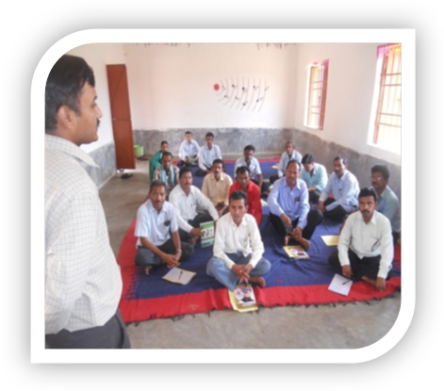
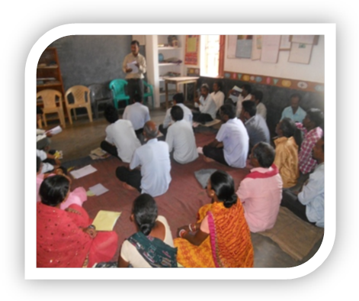
RTE Coordinator Lokadrusti Facilitating SDP Training of SMC /Teachers at Gambhariguda,Singjhar and Makhapadar CRCC of Sinapali block

