**A BRIEF REPORT OF THE SHARING SESSION BETWEEN SRI JAYRAM RAMESH, HONORABLE MINISTER, R.D., GoI AND WONC, DATED 16/02/2013 AT NUAPADA, ODISHA**

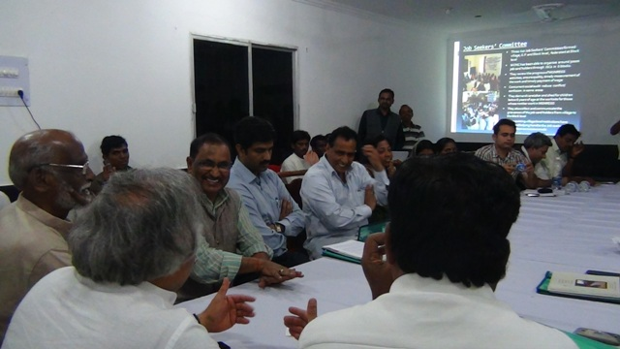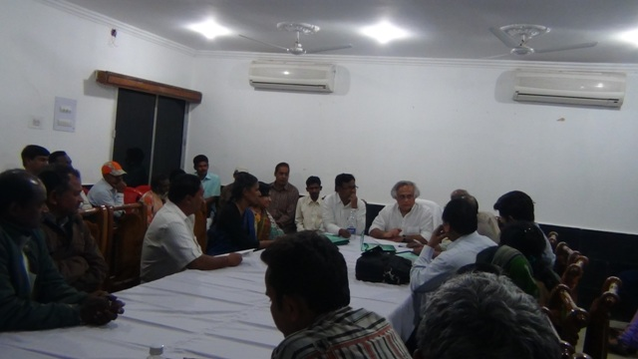A sharing session was organized between Sri Jayram Ramesh, honorable Minister for Rural Development, Government of India and the eight partner organizations of Western Odisha NREGA Consortium at the Circuit House of Nuapada at 8 P.M. during the visit of the minister to the district. Also present in the meeting were Sri Bhakta Charan Das, honorable Member of Loksabha, Kalahandi, honorable Sri A.V. Swami, Member of Rajya Sabha, Chitra madam, MGNREGS Head, Panchyatiraj dept. Government of Odisha, Bhubaneswar, Mrs Guha Punam Naik District Collector Nuapada, Sri Vineel R. Krishnan (IAS) Ministry of RD, Govt. of India, members of the partner organizations, Sarpanch, Panchyat Samiti members, Job Seeker Committee members, Sri Sarat Chandra Ratha coordinator National consortium ,SPS Madhya Pradesh and some journalists.

WONC is a consortium of eight NGOs; one from Nuapada and seven from Bolangir district working to strengthen NREGA in the drought and migration-prone Gram Panchayats from six Blocks of these districts. The total number of villages covered is 266. In the beginning there was a brief PP presentation from WONC outlining the basic characteristics of the operational villages and the justification of intervention. The basic objectives of this intervention which has been continuing since 2006 are facilitation, mobilization and policy reforms. This area is highly migration prone and hundreds of families migrate to other areas in search of livelihood in distress condition. So the focus is to create livelihood opportunities through NREGA activities and thereby stem distress migration. WONC presentation focused on three basic strategies- formation of Job Seekers’ Committees from village to the Block level and federated at Block level. This is basically a committee of the job seekers and they are given training and exposure for their capacity building. They are playing the role of facilitator for the effective implementation of NREGA. The second strategy is the developing Village Micro Plan which is a holistic village level document outlining all the relevant information and planning thereof. This is done in a participatory process involving the villagers. The social mapping is another important component which identify migration-sensitive households in the operational villages.

The honorable Minister desired to know whether NREGA can be a effective instrument to curb Maoism and has there been any such example. The WONC partner, especially Sri Abani Mohan Panigrahi from Lokadrusti stressed that MGNREGS gives an opportunity to reach to the poor people and bring them into the mainstream. This indirectly helps curb migration. But other important approaches include covering the women under this programme and having regular dialogue with them. Maoism is increasing because the administration is not able to reach them. Strengthening SHGs and other village level institutions and bringing about convergence of MGNREGS with other government schemes will be more useful for the effective implementation of MGNREGS. Sri A.V. Swami categorically said that since these NGOs are working Maoism has been limited to certain villages or else it would have spread 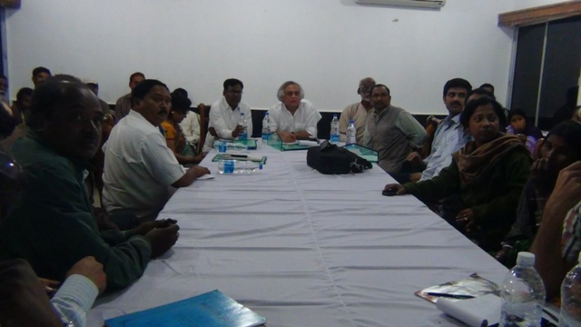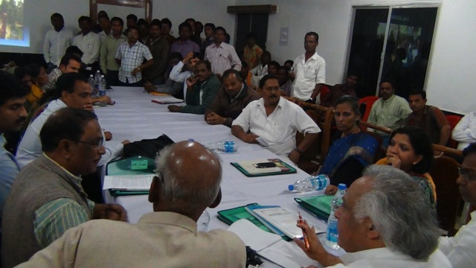to all the villages of the district.

Mr. A.M Panigrahi also suggested the house how to reduce the impact of Maoism. First of all we should have to make a strategy to create a space for dialogue among the villagers. Secondly the women centric development to be initiated. Micro plan should be develop with the active participation of the people by covering all line departments working at Panchayat. This include social problem of the village also. Thirdly the palli sabha and gramsabha to be strengthened through regular concurrent social audit and the youth should be focal point of all initiations. The partner NGO like Adhikar and Janamukti Anusthan share their experience during last five years initiation of WONC. The revered Minister also wanted to know about distress migration and how the WONC has restricted this by virtue of their intervention. He also wanted to know in clear term whether migration has been reduced in the WONC operational villages and if there was any available data to justify this claim. The WONC partners narrated a number of case studies where in livelihood options have increased through NREGA activities. For example in many villages farm pond, land development, work order at the appropriate time have increased employment opportunities. By farm pond protective irrigation has increased giving more yield, work order before Nuakhai (the principal agrarian festival during which the laborers take advance to migrate) have broken the debt and obviously the migration cycle. The overall reduction of migration from 2008-09 to 2001-12 is around 45% in the WONC intervention villages and the honorable Minister expressed his satisfaction. Chitra Madam from Panchayat Raj Dept. told about her experience working with WONC through OMEGA project in Bolangir district particularly in 22 Grampanchayats. She told about how the Panchayat could make their respective micro plan with the help of WONC and pass the micro plan in last Pallisabha and Gramsabha with the active participation of villagers. The house also shared about the PalliSabha and GramSabha Sasaktikaran Yojana organized by Panchayatiraj Dept. of Govt. of Odisha last year. Such type of activities has activised the people participation at grass root. The Pallisabha and Gramsabha to be organized at least bi- monthly to revisit the action plan and make concurrent social audit and solve the problem face by job seeker from time to time. This regular dialogue will reduce the pressure of Panchayat and Block while organizing annual Pallisabha and Gramsabha.

At the end Honorable Minister wanted to know the expectation from WONC from the Government and the presentation had a slide on that. The expectations from the Government were:

* Recognition of Job Seekers’ Committees
* Creating more space for JSC to play major role in MGNREGA
* Incorporation and replication of Micro-plan prepared by the community
* Timely acceptance of Job demand by JSC
* More convergence of MGNREGA with other government programme especially in left wing drought prone area

Responding to this honorable Sri Jayram Ramesh declared that all the left out small and marginal farmers which come to around 15000 (in Nuapada Dist) will be covered under MGNREGA by June this year. He wanted the District Collector to take it up and prepare the list on a mission mode. He also declared that all more and more number of women will be covered under SHG and a regular dialogue will be initiated with them and the village youths to restore their confidence. Chita Madam and the District Collector also agreed and assured that they would do the work within the stipulated time. Going a step ahead Chitra Madam announced that the laborers of Nuapada will be paid Rs. 150/ under MGNREGA.

The session continued for one hour and on the whole it was a meaningful interaction.

---------------------------------------------------------------

------------------------------------------------------------------